**THE PATTERNS COMPANY**

4th Floor, Bizness Square Junction Opposite Hitex Road, HITEC City, Madhapur, Hyderabad, Telangana 500084

+91-8500693113

+91-9392744210

[info@thepatternscompany.com](mailto:info@thepatternscompany.com)

https://[www.thepatternscompany.com/](http://www.thepatternscompany.com/)





Website Report for [www.medicoverhospitals.in](http://www.medicoverhospitals.in/)

This report grades your website based on the strength of various SEO factors such as On Page Optimization, O Page Links, Social and more. The overall Grade is on a A+ to F- scale, with most major, industry leading websites in the A range. Improving your grade will generally make your website perform better for users and rank better in search engines. There are recommendations for improving your website at the bottom of the report. Feel free to reach out to us if you’d like us to help with improving your website’s SEO!

Audit Results for [www.medicoverhospitals.in](http://www.medicoverhospitals.in/)

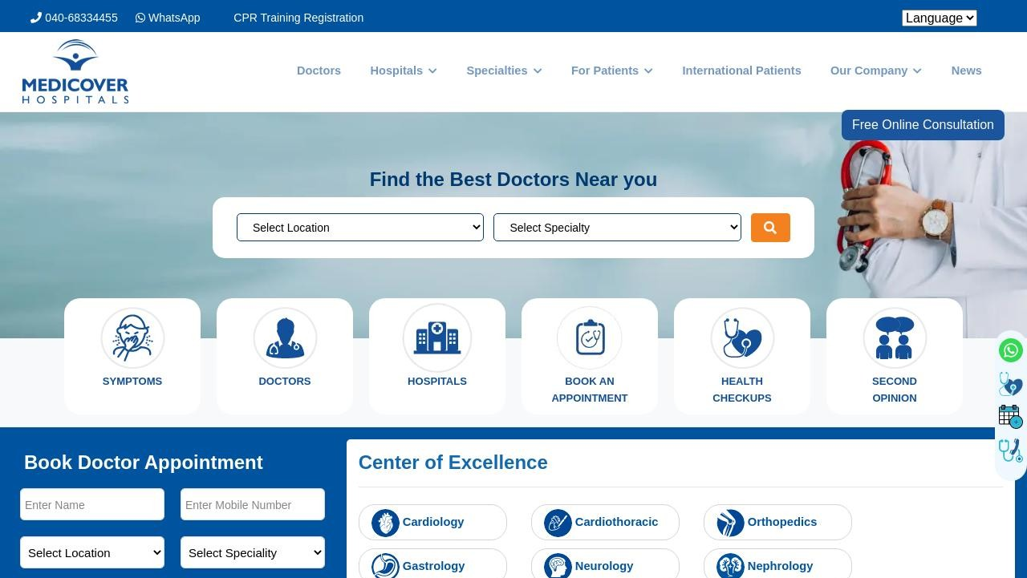

**B**

**Your page could be better**

Recommendations: 16

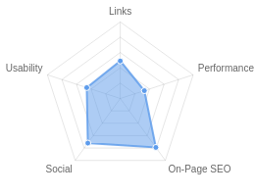



**A**



**C+**



**C**



**D+**



**A-**

On-Page SEO

Links

Usability

Performance

Social

Recommendations

# Improve site load speed

Performance

Medium Priority

**Reduce length of title tag (to between 10 and 70 characters)**

On-Page SEO

Medium Priority

# Shorten meta description (to between 70 and 160 characters)

On-Page SEO

Medium Priority

**Optimize your page for Mobile PageSpeed Insights**

Usability

Low Priority

# Optimize your page for Desktop PageSpeed Insights

Usability

Low Priority

**Increase page text content**

On-Page SEO

Low Priority

# Make use of HTTP/2+ protocol

Performance

Low Priority

**Update Link URLs to be more human and Search Engine readable**

Links

Low Priority

# Review and Increase Font Sizes across devices

Usability

Low Priority

**Improve the size of tap targets**

Usability

Low Priority

# Setup & Install a Facebook Pixel

Social

Low Priority

**Remove any Deprecated HTML**

Performance

Low Priority

# Remove inline styles

Performance

Low Priority

**Resolve JavaScript errors**

Performance

Low Priority

# Add Twitter Cards

Social

Low Priority

**Add Local Business Schema**

Other

Low Priority

On-Page SEO Results

# Your On-Page SEO is good



**A**

Your page is mostly optimized for On-Page SEO performance. On-Page SEO is important to ensure Search Engines can understand your content appropriately and help it rank for relevant keywords. You can continue to improve your page by ensuring HTML Tag Content is completed correctly and text content is well aligned with chosen keywords.

# Title Tag

You have a title tag, but ideally it should be shortened to between 10 and 70 characters (including spaces).

Best Hospitals in India | Multispecialty Hospitals in india | Medicover Hospitals Length : 81

Title tags are very important for search engines to correctly understand and categorize your content.

# Meta Description Tag

Your page has a meta description tag however, your meta description should ideally be between 70 and 160 characters (including spaces).

Medicover Hospitals is one of the best multispecialty hospitals in India being located at Hyderabad, Vizag, Nashik, Kurnool, Nellore,Karimnagar, Nizamabad, Sangareddy,Zaheerabad,Vizianagaram,Srikakulam and Aurangabad

Length : 216

A meta description is important for search engines to understand the content of your page, and is often shown as the description text blurb in search results.

# SERP Snippet Preview

This illustrates how your page may appear in Search Results. Note, this is intended as a guide and Search Engines are more frequently generating this content dynamically.

[https://www.medicoverhospitals.in](http://www.medicoverhospitals.in/) ⋮

Best Hospitals in India

Medicover Hospitals is one of the best multispecialty hospitals in India being located at Hyderabad, Vizag, Nashik, Kurnool, Nellore,Karimnagar, ...

# Hreflang Usage

Your page is making use of Hre ang attributes.

# Language

Your page is using the lang attribute. Declared: English

# H1 Header Tag Usage

Your page has a H1 Tag.

# H2-H6 Header Tag Usage

Your page is making use multiple levels of Header Tags.

Header Tag Frequency

H2 10

H3 0

H4 8

H5 9

H6 5

# Keyword Consistency

Your page's main keywords are distributed well across the important HTML tags.

Individual Keywords

Keyword Title Meta Description

Tag

Headings Tags Page Frequency

medicover    8

hospital    8

hospitals    7

health    7

hyderabad    5

india    5

care    5

select    4

Phrases

Phrase Title Meta Description

Tag

24-aug-23 by

medicover







3

Headings Tags Page Frequency

medicover hospital    3

navi mumbai    3

nashik aurangabad    3

kurnool nellore    3

karimnagar nizamabad

health care    3

   3

chandanagar karimnagar nizamabad

   2

# Amount of Content

Your page has a low volume of text content which search engines can interpret as 'thin content'.

Word Count: 444

It has been well researched that higher text content volumes are related to better ranking ability in general.

# Image Alt Attributes

You do not have any images missing Alt attributes on your page.

# Canonical Tag

Your page is using the Canonical Tag.

https://[www.medicoverhospitals.in/](http://www.medicoverhospitals.in/)

# Noindex Tag Test

Your page is not using the Noindex Tag which prevents indexing.

# Noindex Header Test

Your page is not using the Noindex Header which prevents indexing.

# SSL Enabled

Your website has SSL enabled.

# HTTPS Redirect

Your page successfully redirects to a HTTPS (SSL secure) version.

# Robots.txt

Your website appears to have a robots.txt le.

<http://www.medicoverhospitals.in/robots.txt>

# Blocked by Robots.txt

Your page does not appear to be blocked by robots.txt.

# XML Sitemaps

Your website appears to have an XML sitemap.

https://[www.medicoverhospitals.in/sitemap.xml](http://www.medicoverhospitals.in/sitemap.xml)

https://[www.medicoverhospitals.in/sitemap.articles.xml](http://www.medicoverhospitals.in/sitemap.articles.xml)

https://[www.medicoverhospitals.in/sitemap.coronavirus.xml](http://www.medicoverhospitals.in/sitemap.coronavirus.xml)

https://[www.medicoverhospitals.in/sitemap.doctor-speciality.xml](http://www.medicoverhospitals.in/sitemap.doctor-speciality.xml)

https://[www.medicoverhospitals.in/sitemap.doctors-location-wise.xml](http://www.medicoverhospitals.in/sitemap.doctors-location-wise.xml)

https://[www.medicoverhospitals.in/sitemap.doctors.xml](http://www.medicoverhospitals.in/sitemap.doctors.xml)

https://[www.medicoverhospitals.in/sitemap.homepage.xml](http://www.medicoverhospitals.in/sitemap.homepage.xml)

https://[www.medicoverhospitals.in/sitemap.hospitals.xml](http://www.medicoverhospitals.in/sitemap.hospitals.xml)

https://[www.medicoverhospitals.in/sitemap.medicine.xml](http://www.medicoverhospitals.in/sitemap.medicine.xml)

https://[www.medicoverhospitals.in/sitemap.news-room.xml](http://www.medicoverhospitals.in/sitemap.news-room.xml)

More Sitemaps were found, but not tested.

# Analytics

Your page is using an analytics tool.



Google Analytics

# Schema.org Structured Data

You are using JSON-LD Schema on your page.

Rankings

# Top Keyword Rankings

This shows your top 10 Keyword Rankings in the speci c location. The list is ordered by the keywords that drive the most tra c to your page.

Keyword Country & Language

Position Total

Searches

Estimated Tra c



AR 8 3,350,000 65,995

loose motions  EN 1 110,000 33,440



hospitals HI 6 673,000 22,747

zerodol p  HI 3 201,000 19,557



gb wata HI 67 9,140,000 19,194

nimesulide tablet uses  HI 1 60,500 18,392



hospitals EN 7 673,000 17,228

hospital  HI 8 673,000 13,258



aceclofenac EN 3 135,000 13,135

twitching  EN 51 6,120,000 12,852

# Total Traffic From Search

This shows you the Estimated Tra c Volume your page receives from it’s Keyword Rankings



**9,030,839**

Monthly Tra c Volume

# Keyword Positions

This shows you a summary of the positions for your Keyword Rankings. The higher you rank, the more likely you are to capture tra c, with recent research showing that as much as 92% of clicks happen on the rst page.

Position Keywords

Position 1 4,627

Position 2-3 16,819

Position 4-10 81,804

Position 11-20 122,629

Position 21-30 117,914

Position 31-100 628,222

Links

# Backlink Summary

You have a strong level of backlink activity to this page.



**54**



**20**

Domain Strength

Page Strength





**30.2k**

Backlinks

**3.5k**

Referring Domains

|  |  |  |  |  |  |
| --- | --- | --- | --- | --- | --- |
| **17.4k**  Nofollow Backlinks | **12.8k**  Dofollow Backlinks | **4**  Edu Backlinks | **4**  Gov Backlinks | **1.6k**  Subnets | **2.9k**  IPs |

# Top Backlinks

These are the highest value external pages we have found linking to your site.

Domain strength

Referring Page URL

100 https://in.pinterest.com/MedicoverHospitalss/

100 https://www.google.com/imgres?imgurl=https://[www.medicoverhospitals.in/wp-content/upload](http://www.medicoverhospitals.in/wp-content/upload) s/2019/08/Gout-A-form-of-Arthritis-1024x546-1024x438.jpg&imgrefurl=https://www.medicoverho spitals.in/gouty-arthritis-gout/&tbnid=m63GzaNXIiPdFM&vet=1&docid=riCwVzfIO-8TUM&w=1024 &h=438&q=Gout

96

https://[www.bing.com/images/search?&q=Down%27s+Syndrome&qft=+](http://www.bing.com/images/search?&q=Down%27s%2BSyndrome&qft=%2B) lterui:imagesize-mediu

m&FORM=IRFLTR

96 https://4.bing.com/images/search?&q=Aesthetic+Dentistry&qft=+ lterui:photo-transparent+ lter ui:imagesize-large&FORM=IRFLTR

95

https://blogs.cornell.edu/advancedrevenuemanagement12/2012/03/27/internet-cafe-in-asia-3/co

mment-page-2/

94 https://[www.healthline.com/health-news/urinary-tract-infections-a-new-antibiotic-may-be-on-the-](http://www.healthline.com/health-news/urinary-tract-infections-a-new-antibiotic-may-be-on-the-) way-to-treat-utis

94 https://[www.wikihow.com/Clear-Chest-Congestion](http://www.wikihow.com/Clear-Chest-Congestion)

93 https://[www.yandex.com/yandsearch?text=Shopping+Health+Conditions+and+Diseases+Urologic](http://www.yandex.com/yandsearch?text=Shopping%2BHealth%2BConditions%2Band%2BDiseases%2BUrologic) al+Disorders

93 https://[www.mdpi.com/1420-3049/27/16/5327/htm](http://www.mdpi.com/1420-3049/27/16/5327/htm)

93 https://blog.ssa.gov/mens-health-and-social-security/comment-page-21/

# Top Pages by Backlinks

These are the pages on your site with the most the backlinks from other sites.

URL Backlinks

<http://medicoverhospitals.in/> 1,213

https://[www.medicoverhospitals.in/](http://www.medicoverhospitals.in/) 1,055

<http://www.medicoverhospitals.in/> 789

https://[www.medicoverhospitals.in/medicine/nifedipine](http://www.medicoverhospitals.in/medicine/nifedipine) 532

https://[www.medicoverhospitals.in/medicine/enalapril](http://www.medicoverhospitals.in/medicine/enalapril) 483

https://[www.medicoverhospitals.in/medicine/carvedilol](http://www.medicoverhospitals.in/medicine/carvedilol) 480

https://[www.medicoverhospitals.in/medicine/bisoprolol](http://www.medicoverhospitals.in/medicine/bisoprolol) 476

https://[www.medicoverhospitals.in/medicine/hydralazine](http://www.medicoverhospitals.in/medicine/hydralazine) 467

https://[www.medicoverhospitals.in/medicine/atenolol](http://www.medicoverhospitals.in/medicine/atenolol) 463

https://[www.medicoverhospitals.in/wp-content/uploads/2019/08/skin-rash...](http://www.medicoverhospitals.in/wp-content/uploads/2019/08/skin-rash) 435

# Top Anchors by Backlinks

These are the top pieces of Anchor Text we found used to link to your site.

Anchor Backlinks

Go Now 5,334

Six Possible Side E ects Of Vitamin B Overdose Medicover Hospitals 1,097

Nasik 814

Ashoka Medicover, Nasik 731

Click here 573

medicoverhospitals.in 481

[www.medicoverhospitals.in](http://www.medicoverhospitals.in/) 283

Go Health 249

https://[www.medicoverhospitals.in/medicine/hydralazine](http://www.medicoverhospitals.in/medicine/hydralazine) 215

# Top Referring Domain Geographies

These are the Top Geographies we have found linking to your site.

Top TLDs Top Countries

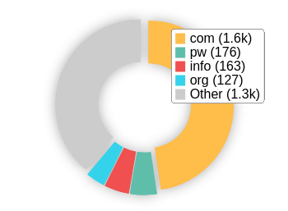 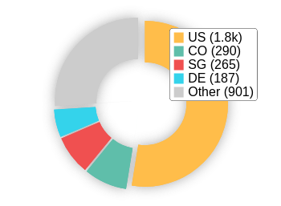

# On-Page Link Structure

We found 114 total links. 4% of your links are external links and are sending authority to other sites. 0% of your links are nofollow links, meaning authority is not being passed to those destination pages.

# Friendly Links

Some of your link URLs do not appear friendly to humans or search engines.

We would recommend making URLs as readable as possible by reducing length, le names, code strings and special characters.

Usability

# Your usability could be better



**C**

Your page is OK but could be more usable across devices. Usability is important to maximize your available audience and minimize user bounce rates (which can indirectly a ect your search engine rankings).

# Device Rendering

This check visually demonstrates how your page renders on di erent devices. It is important that your page is optimized for mobile and tablet experiences as today the majority of web tra c comes from these sources.

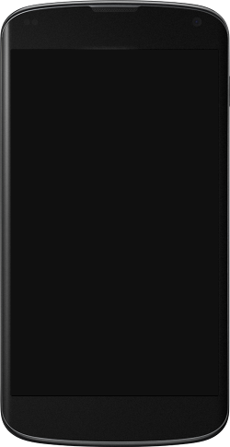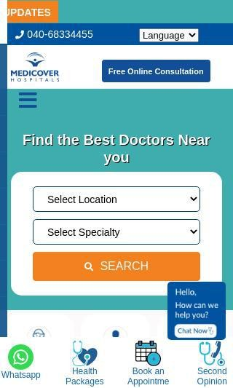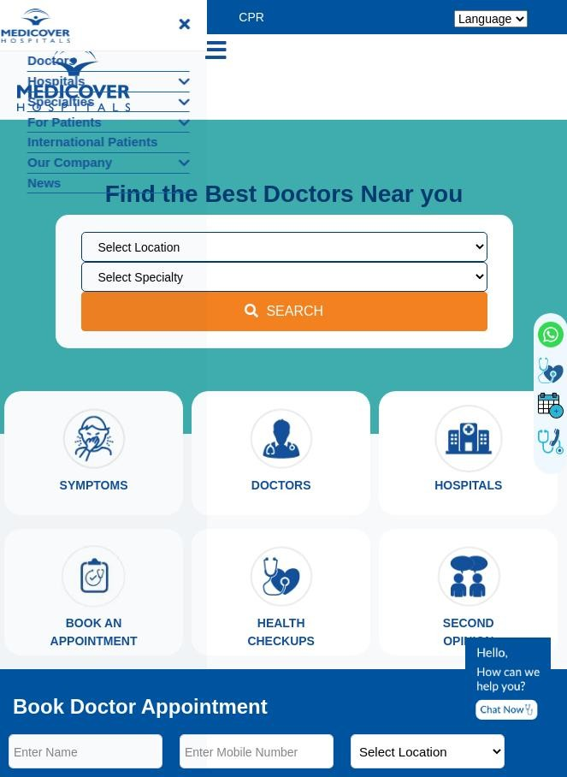

# Google's Core Web Vitals

Your page has passed Google's Core Web Vitals assessment.

Largest Contentful Paint (LCP)

First Input Delay (FID)

Cumulative Layout Shift (CLS)

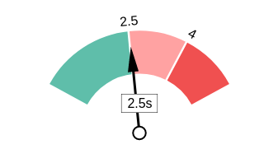 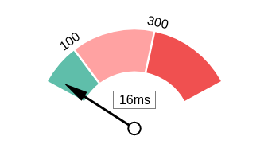 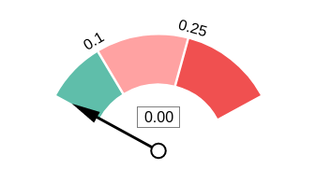

# Use of Mobile Viewports

Your page speci es a viewport matching the device's size, allowing it to render appropriately across devices.

# Google's PageSpeed Insights - Mobile

Google is indicating that your page is scoring poorly on their Mobile PageSpeed Insights evaluation.

Note that this evaluation is being performed from US servers and the results may di er slightly from an evaluation carried out from Google's PageSpeed Web Interface as that reporting localizes to the region in which you are running the report.

Google has indicated that the performance of a webpage is becoming more important from a user and subsequently ranking perspective.



**30**

Opportunities Estimated Savings

Eliminate render-blocking

resources

3.77 s

|  |  |
| --- | --- |
| Lab Data | Value |
| First Contentful Paint | 6.5 s |
| Speed Index | 14.3 s |
| Largest Contentful Paint | 7.9 s |
| Time to Interactive | 12.3 s |
| Total Blocking Time | 0.69 s |
| Cumulative Layout Shift | 0 |

Avoid multiple page redirects 0.63 s

Reduce unused JavaScript 0.49 s

Initial server response time was short

0.16 s

Minify JavaScript 0.15 s

# Google's PageSpeed Insights - Desktop

Google is indicating that your page is scoring poorly on their Desktop PageSpeed Insights evaluation.

Google has indicated that the performance of a webpage is becoming more important from a user and subsequently ranking perspective.



**47**

Opportunities Estimated Savings

Eliminate render-blocking

resources

3.75 s

|  |  |
| --- | --- |
| Lab Data | Value |
| First Contentful Paint | 5.3 s |
| Speed Index | 7.2 s |
| Largest Contentful Paint | 12.5 s |
| Time to Interactive | 6.7 s |
| Total Blocking Time | 0.01 s |
| Cumulative Layout Shift | 0.004 |

Reduce unused CSS 0.56 s

Avoid multiple page redirects 0.19 s

Initial server response time was short

0.15 s

# Flash Used?

No Flash content has been identi ed on your page.

# iFrames Used?

There are no iFrames detected on your page.

# Favicon

Your page has speci ed a favicon.

# Email Privacy

No email addresses have been found in plain text on your page.

# Legible Font Sizes

There is some text on your page that is small and may not be legible enough for particular users.

We recommend reviewing all text on your page in di erent devices to ensure that it is of appropriate size.

# Tap Target Sizing

Some of the links or buttons on your page may be too small for a user to easily tap on a touchscreen. Consider making these tap targets larger to provide a better user experience.

Performance Results

# Your performance could be better



**D+**

Your page's performance has some issues and room for improvement. Performance is important to ensure a good user experience, and reduced bounce rates (which can also indirectly a ect your search engine rankings). We recommend addressing the highlighted factors below.

# Page Speed Info

Your page loads slowly.

Page load speed is critical to ensuring good user experience and is becoming a more important ranking factor. Load speed can be impacted by a multitude of factors however and may need technical resources to investigate.

Server Response All Page Content Loaded All Page Scripts Complete

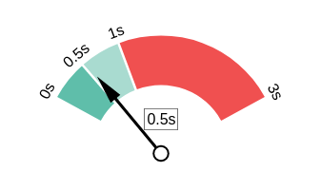 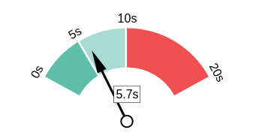 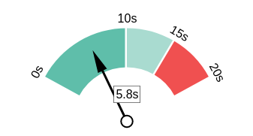

# Download Page Size

Your page's le size is reasonably low which is good for Page Load Speed and user experience.

Download Page Size Download Page Size Breakdown

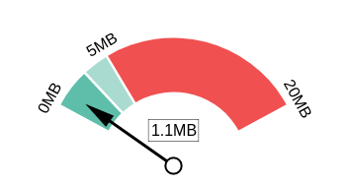 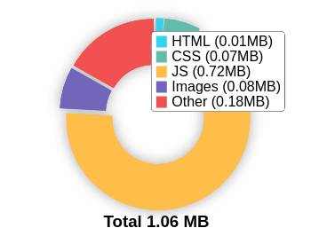

# Website Compression (Gzip, Deflate, Brotli)

Your website appears to be using a reasonable level of compression.

Compression Rates Raw Page Size Breakdown

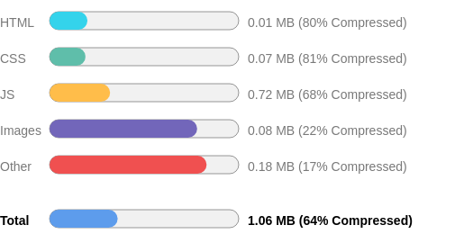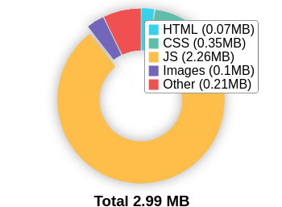

# Number of Resources

This check displays the total number of les that need to be retrieved from web servers to load your page.



**70**

Total Objects

**2**

Number of HTML Pages

**19**

Number of JS Resources

**4**

Number of CSS Resources

**35**

Number of Images

**10**

Other Resources

# Google Accelerated Mobile Pages (AMP)

This page does not appear to have AMP Enabled.

# JavaScript Errors

Your page is reporting JavaScript errors during load.

This could indicate that some required functionality on your page is failing or scripts may have coding problems.

# HTTP2 Usage

Your website is using an outdated HTTP protocol.

We recommend enabling HTTP/2+ or protocol for your website as it can signi cantly improve page load speed for users.

# Optimize Images

All of the images on your page appear to be optimized.

# Minification

All your JavaScript and CSS les appear to be mini ed.

# Deprecated HTML

Deprecated HTML tags have been found within your page.

These tags are no longer o cially supported in modern web browsers, and hence are recommended to be removed as they could cause display issues.

# Inline Styles

Your page appears to be using inline styles.

Inline styles are an older coding practice and discouraged in favor of using CSS style sheets, due to their ability to degrade page load performance and unnecessarily complicate HTML Code.

Social Results

# Your social is good



**A-**

You have a reasonably good social presence. Social activity is important for customer communication, brand awareness and as a marketing channel to bring more visitors to your website. We recommend that you have all of your pro les listed on your page, and work to build a larger following on those networks.

# Facebook Connected

Your page has a link to a Facebook Page.

# Facebook Open Graph Tags

Your page is using Facebook Open Graph Tags.

# Facebook Pixel

We have not detected a Facebook Pixel on your page.

Facebook's Pixel is a useful piece of analytics code that allows you to retarget visitors if you decide to run Facebook Ads in future.

# Twitter Connected

Your page has a link to a Twitter pro le.

# Twitter Cards

We have not detected Twitter Cards on your page.

Twitter Cards are a type of structured data that can be placed on your page to control what content is shown when a page is shared on Twitter.

# Instagram Connected

Your page has a link to an Instagram pro le.

# LinkedIn Connected

Your page has a link to a LinkedIn pro le.

# YouTube Connected

Your page has a link to a YouTube channel.

# YouTube Activity

You have a good number of YouTube channel subscribers

 

**64,400**

Followers

**14,488,405**

View Count

Local SEO

# Local Business Schema

No Local Business Schema identi ed on the page.

# Google Business Profile Identified

A Google Business Pro le was identi ed that links to this website.



Medicover Hospitals main block

# Google Business Profile Completeness

The important business details are present on the Google Business Pro le.

Address Opposite Cyber Gateway, lane besides Venk Enclave, HITEC City, Hyderabad, Telangana

Phone +91 40 6833 4455

l

Site

https://[www.medicoverhospitals.in/hospita](http://www.medicoverhospitals.in/hospita)

city/

# Google Reviews

The Google Business Pro le has a good rating and review count.

4.1

★★★★★

258 reviews

Rating

5

4

3

2

1

Technology Results

# Technology List

These software or coding libraries have been identi ed on your page.

Technology Version



Apache HTTP Server 2.4.57

 Bootstrap



Font Awesome

 Google Analytics



Google Tag Manager

 HubSpot Analytics



jQuery

 jQuery CDN



OpenSSL 1.0.2k

PHP 7.2.34

# Server IP Address

13.235.191.177

# DNS Servers

dns1.cscdns.net dns2.cscdns.net

# Web Server

Apache/2.4.57 () OpenSSL/1.0.2k- ps

# Charset

text/html; charset=UTF-8



https://www.thepatternscompany.com/

**The Purpose of a Business is to create a Customer Who Creates Customer’s**

**Thank you**